2APHY: Motion and Force: Unit Test. ANSWERS

Name: ________________ANSWERS___________________________ (40 marks)
- Stephenie is in Venice on a round the world tour. She travels across an old arched bridge to get to her favourite café. The arch bridge has a walkway with an arched length of 7.50 m but a bridge span of only 6.80 m.
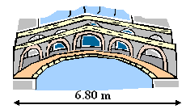

If it takes Stephanie 4.50 s to cross the bridge, calculate:
- Stephanie’s speed. (2 marks) b. Stephanie’s velocity. (2 marks)
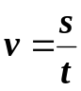
Speed = distance
t
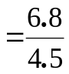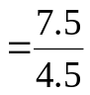
speed = 1.67 ms⁻¹ v = 1.51 ms⁻¹

- Victoria works in Coles doing night fill. She has to lift three 1.50 kg boxes of laundry detergent from the floor to the shelf 1.10 m above the floor. If it took 1.50 seconds to lift all boxes at once to the shelf, what power was required? (2 marks)

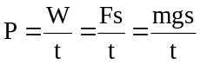
m = 3 x 1.5
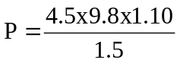 = 4.5 kg
s = 1.10 m
g = 9.8 ms⁻²
t = 1.5 s
P = 32.3 W

- A hot-air balloon, total mass 9.00 x 10¹ kg has a horizontal ground velocity of 105 kmh⁻¹. As it increases its altitude to 2.00 x 10³ m, its gravitational potential energy is increased by 17.64 MJ. How much work was done? (Note: M is mega which is 1 x 10⁶) (2 mark)

As work is equivalent to energy and
17.6 MJ of energy have been used, then

Work = 17.64 MJ

- Michael is a world champion runner and can reach a maximum velocity of at least 10.1 ms⁻¹.
If Michael’s mass is 58.0 kg, determine his kinetic energy. (2 marks)

v = 10.1 ms⁻¹ E_{k} = 0.5mv²
m = 58 kg = 0.5 x 58 x 10.1²
E_{k} = 2.96 x 10³ J

- Casey is walking to the shops. He is walking along at a fast but comfortable velocity. He then starts to climb a hill and finds that to maintain the same velocity is much harder. Using your understanding of physics, explain why it is harder to walk up a hill than to walk on a flat path.
(2 marks)

When walking along a path, the work you are using is kinetic energy (0.5mv²). When you walk up a hill, you still have kinetic energy but now you do extra work to increase your potential energy (mgh) so the work to get up the hill is your kinetic energy plus your potential energy. NOTE: If you walk at the same velocity, your power doesn’t change as the time you are travelling is the same.

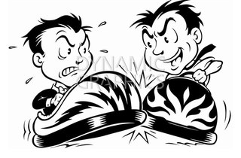
- Simon and Shaun are at the Royal Show on the bumper cars. The two boys have the same mass as do the bumper cars so the total mass of each is car and rider is 170 kg. Simon is heading east towards Shaun at 3.50 ms⁻¹ and hits Shaun’s car head on. Simon’s car rebounds at 1.90 ms⁻¹ and Shaun’s car rebounds at 2.50 ms⁻¹. What was the initial velocity of Shaun’s car?
(2 marks)

m₁u₁ + m₂u₂ = m₁v₁ + m₂v₂
(170 x 3.50) + (170 x u₂) = (170 x -1.90) + (170 x 2.50)
595 + 170u₂ = -323 + 425
170u₂ = -323 + 425 - 595
170u₂ = -493
u₂ = -2.90 ms⁻¹
Shaun’s car was initially travelling at 2.90 ms⁻¹ west

- Jasmine, who has a mass of 60.0 kg, is a triathlete in training for the bicycle component of the event. She is riding her bicycle (28.0 kg) at a constant velocity of 50.4 kmh⁻¹ on a flat surface. The combined frictional forces are 45.0 N. She maintains her velocity for 12.0 s.
- What force does Jasmine need to overcome in order to move with a constant velocity? (2 mark)

As the frictional forces are 45.0 N then this is the force
that Jasmine needs to overcome.

Frictional force = 45.0 N

- Calculate the work done by Jasmine. (2 marks)

v = 50.4
= 14 ms⁻¹

Firstly find displacement Work = Fs
s = vt = 45 x 168
= 14 x 12 Work = 7.56 x 10³ J
= 168 m

- What is Jasmines’s power output? (2 marks)

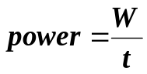

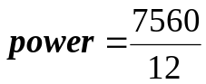
power = 630W

- On the diagram of Matthew, show the forces acting on him and label them appropriately. (2 marks)
reaction force from ground

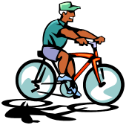

friction forward force

NB: All forces equal as constant
velocity.
weight

- William, a non-physics student, is asked by his mum to help push a car trailer out of the way. William tells his mum that there is no point as Newton’s Third Law states that every force produces an equal and opposite force so if he pushes the car trailer, the car pushes back so nothing moves. Explain Newton’s Third Law to William and why he is able to push the car trailer out of the way. (3 marks)

Newton’s Third Law states that for every action force there is an equal but opposite reaction force. The main concept here is that the two forces may be equal in size but they are not the same force as they are acting in opposite directions (force is vector). As far as the trailer is concerned, the only force on it is from William applying the force and so as long as his force is great enough, the trailer will move. William finds the trailer hard to move as the trailer is applying a force onto him. Also, there is a force on William’s feet from the ground which he can use to push the trailer forward

- Simon is off to Mars for his holidays. (Mars has an acceleration due to gravity of 3.4 ms⁻²). His suitcase has a mass of 25 kg on Earth. Simon notices that his suitcase is always much easier to carry on Mars.
  - Calculate the mass and weight of Simon’s suitcase on Mars. (2 marks)

mass = 25 kg F_{w} = mg
= 25 x 3.4
F_{w} = 85 N

  - Why do you think that Simon’s suitcase is easier to carry on Mars? (1 marks)

Weight is mass acted on by gravity. As the gravity is less on Mars, the weight is less and the suitcase is therefore easier to carry.

- Which pedal of the car is being used when
- the net force acting on the car is in the opposite direction as the car’s velocity
brake (1 mark)
- the net force and velocity are in the same direction?
accelerator (1 marks)
- A sand blaster is used to strip paint from a house. The sand blaster throws the sand against the wall with a velocity of 50.0 ms⁻¹, and it rebounds in the opposite direction at an average velocity of 8.00 ms⁻¹. Find the average force on the house if 0.2 kg hits it each second. (2 marks)

u = 50.0 ms⁻¹ Ft = m(v – u)
v = -8.00 ms⁻¹ F x 1 = 0.2 (-8 – 50)
m = 0.2 kg F = -11.6 N
t = 1.0 s OR
F = 11.6 N is the force on the house

- a. Ryan is on a sightseeing tour in a helicopter. When the helicopter is travelling downwards at 18 kmh⁻¹, Ryan looks out of the window and his 100 g sunglasses fall off. If the glasses were 140 m above the ground when they fell off, with what velocity will the sunglasses hit the ground?
(2 marks)

u = 18 kmh⁻¹ v² = u² + 2gs
= 5.0 ms⁻¹ = (5²) + (2 x 9.8 x 140)
v = ? = 25 + 2744
m = 0.10 kg = 2769
s = 140 m v = 52.6 ms⁻¹
g =9.8 ms⁻²

- The glasses landed in soft sand. If it took 0.006 s to stop, what force was applied to the sunglasses? (2 marks)
Note: The wrong time was in the question you had and should have been as above.

u = 52.6 ms⁻¹ F = m (v – u) F
v = 0 t
t = 0.40 s F = 0.10 (0 – 52.6) F = 0.10 (0 – 52.5)
m = 0.10 kg 0.006 0.4
F = -877 N or 877 N in opposite = -13.15 N or 13.15 N opposite direction
directio n to initial
Motion as force on sunglasses (up)

c. Calculate the glasses acceleration between hitting the ground and stopping. (2 marks)

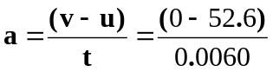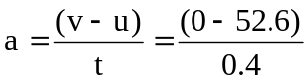
a = -8767 ms⁻² = -131.5 ms⁻²

d. Calculate the displacement of the glasses between hitting the ground and stopping. (2 mark)

v² = u² + 2as
- = (52.6²) + (2 x -8767 x s)
0 = 2767 - 17533s
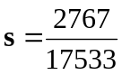
s = +0.158 m

v² = u² + 2as
- = (52.6²) + (2 x -131.5 x s)
0 = 276.76 - 263s
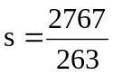
s = 10.52 m which is obviously incorrect

BONUS QUESTION: Not to be attempted unless the test is finished.
Dangerous Dan is travelling along the road at a constant 90 kmh⁻¹ (unfortunately for Dan the speed limit is 60 kmh⁻¹). Dan’s car passes policeman Bob who on his stationary police bike just as Bob starts to accelerate his bike at 6.8 ms⁻² to catch Dan and book him. How far will the car travel before the police bike reaches it? (3 marks)

v = 90 kmh⁻¹
v = 25 ms⁻¹

s = vt s = ut + ½ at²
= 25 x t = 0 + ½ x 6.8 x t²
= 25t = 3.4t²
now both displacements are the same so
25t = 3.4t²
25 = 3.4t
t = 7.3529 s

s = 25t
= 25 x 7.3529
= 184 m

